**Week 4(Spring Rest using Spring Boot)**

**Exercise 1: Create a Spring Web Project using Maven**

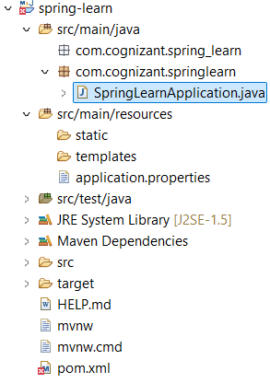

**//pom.xml**

<project xmlns=*"http://maven.apache.org/POM/4.0.0"*

xmlns:xsi=*"http://www.w3.org/2001/XMLSchema-instance"*

xsi:schemaLocation=*"http://maven.apache.org/POM/4.0.0*

*http://maven.apache.org/xsd/maven-4.0.0.xsd"*>

<modelVersion>4.0.0</modelVersion>

<parent>

<groupId>org.springframework.boot</groupId>

<artifactId>spring-boot-starter-parent</artifactId>

<version>3.2.5</version>

<relativePath/> <!-- lookup parent from repository -->

</parent>

<groupId>com.cognizant</groupId>

<artifactId>spring-learn</artifactId>

<version>0.0.1-SNAPSHOT</version>

<packaging>jar</packaging>

<name>spring-learn</name>

<description>Demo Spring Web Project with Logging</description>

<properties>

<java.version>17</java.version>

</properties>

<dependencies>

<!-- Spring Boot Starter Web -->

<dependency>

<groupId>org.springframework.boot</groupId>

<artifactId>spring-boot-starter-web</artifactId>

</dependency>

<!-- Spring Boot DevTools -->

<dependency>

<groupId>org.springframework.boot</groupId>

<artifactId>spring-boot-devtools</artifactId>

<scope>runtime</scope>

</dependency>

<!-- Spring Boot Starter Test -->

<dependency>

<groupId>org.springframework.boot</groupId>

<artifactId>spring-boot-starter-test</artifactId>

<scope>test</scope>

</dependency>

</dependencies>

<build>

<plugins>

<plugin>

<groupId>org.springframework.boot</groupId>

<artifactId>spring-boot-maven-plugin</artifactId>

</plugin>

</plugins>

</build>

</project>

**//application.properties**

# Logging levels

logging.level.org.springframework=INFO

logging.level.com.cognizant.springlearn=DEBUG

# Console pattern

logging.pattern.console=%d{yyMMdd}|%d{HH:mm:ss.SSS}|%-20.20thread|%5p|%-25.25logger**{25}**|%25M|%m%n

# Custom port (optional)

server.port=8081

**//package com.cognizant.springlearn;**

**//--SpringLearnApplication**

package com.cognizant.springlearn;

import org.slf4j.Logger;

import org.slf4j.LoggerFactory;

import org.springframework.boot.SpringApplication;

import org.springframework.boot.autoconfigure.SpringBootApplication;

@SpringBootApplication

public class SpringLearnApplication {

private static final Logger LOGGER = LoggerFactory.getLogger(SpringLearnApplication.class);

public static void main(String[] args) {

LOGGER.info("START");

SpringApplication.run(SpringLearnApplication.class, args);

LOGGER.info("END");

}

}

**Output:**

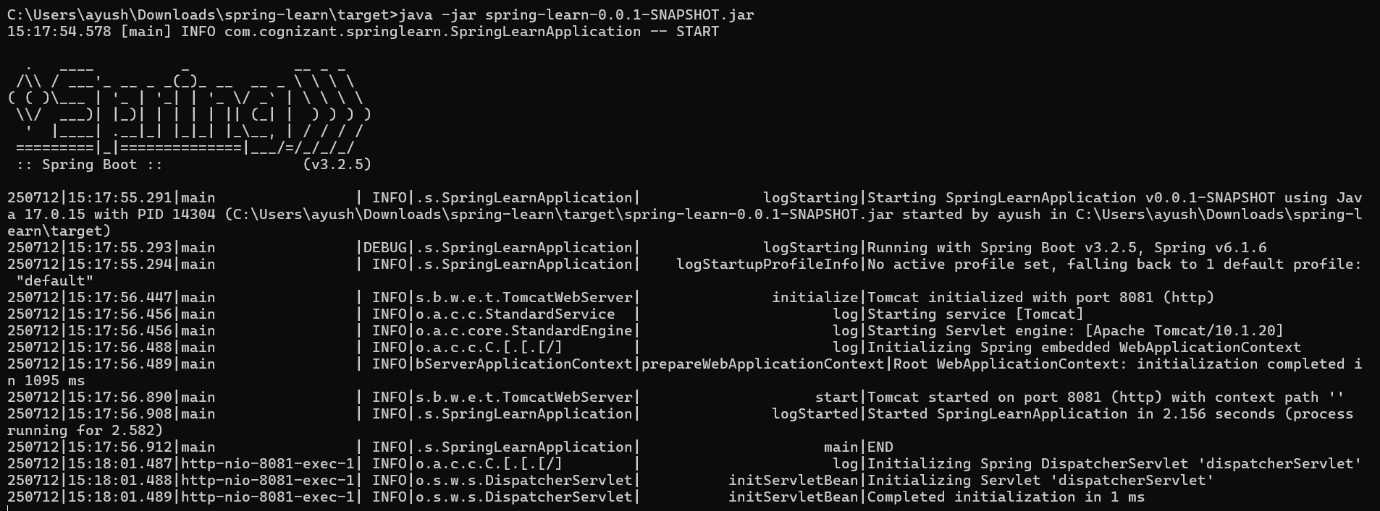

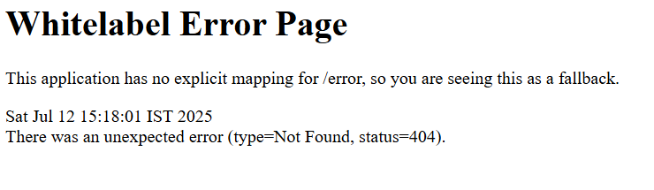

**Exercise 2: Spring Core – Load Country from Spring Configuration XML**

**//pom.xml**

<project xmlns=*"http://maven.apache.org/POM/4.0.0"*

xmlns:xsi=*"http://www.w3.org/2001/XMLSchema-instance"*

xsi:schemaLocation=*"http://maven.apache.org/POM/4.0.0*

*http://maven.apache.org/xsd/maven-4.0.0.xsd"*>

<modelVersion>4.0.0</modelVersion>

<parent>

<groupId>org.springframework.boot</groupId>

<artifactId>spring-boot-starter-parent</artifactId>

<version>3.2.5</version>

<relativePath/> <!-- lookup parent from repository -->

</parent>

<groupId>com.cognizant</groupId>

<artifactId>spring-learn</artifactId>

<version>0.0.1-SNAPSHOT</version>

<packaging>jar</packaging>

<name>spring-learn</name>

<description>Demo Spring Web Project with Logging</description>

<properties>

<java.version>17</java.version>

</properties>

<dependencies>

<!-- Spring Boot Starter Web -->

<dependency>

<groupId>org.springframework.boot</groupId>

<artifactId>spring-boot-starter-web</artifactId>

</dependency>

<!-- Spring Boot DevTools -->

<dependency>

<groupId>org.springframework.boot</groupId>

<artifactId>spring-boot-devtools</artifactId>

<scope>runtime</scope>

</dependency>

<!-- Spring Boot Starter Test -->

<dependency>

<groupId>org.springframework.boot</groupId>

<artifactId>spring-boot-starter-test</artifactId>

<scope>test</scope>

</dependency>

</dependencies>

<build>

<plugins>

<plugin>

<groupId>org.springframework.boot</groupId>

<artifactId>spring-boot-maven-plugin</artifactId>

<configuration>

<mainClass>com.cognizant.springlearn.SpringLearnApplication</mainClass>

</configuration>

</plugin>

</plugins>

</build>

</project>  
  
**//Country.java**

**package** com.cognizant.springlearn;

**import** org.slf4j.Logger;

**import** org.slf4j.LoggerFactory;

**public** **class** Country {

**private** **static** **final** Logger ***LOGGER*** = LoggerFactory.*getLogger*(Country.**class**);

**private** String code;

**private** String name;

**public** Country() {

***LOGGER***.debug("Inside Country Constructor.");

}

**public** String getCode() {

***LOGGER***.debug("Getting country code: {}", code);

**return** code;

}

**public** **void** setCode(String code) {

***LOGGER***.debug("Setting country code: {}", code);

**this**.code = code;

}

**public** String getName() {

***LOGGER***.debug("Getting country name: {}", name);

**return** name;

}

**public** **void** setName(String name) {

***LOGGER***.debug("Setting country name: {}", name);

**this**.name = name;

}

@Override

**public** String toString() {

**return** "Country [code=" + code + ", name=" + name + "]";

}

}

// **SpringLearnApplication**

**package** com.cognizant.springlearn;

**import** java.util.List;

**import** org.slf4j.Logger;

**import** org.slf4j.LoggerFactory;

**import** org.springframework.boot.SpringApplication;

**import** org.springframework.boot.autoconfigure.SpringBootApplication;

**import** org.springframework.context.ApplicationContext;

**import** org.springframework.context.support.ClassPathXmlApplicationContext;

@SpringBootApplication

**public** **class** SpringLearnApplication {

**private** **static** **final** Logger ***LOGGER*** = LoggerFactory.*getLogger*(SpringLearnApplication.**class**);

**public** **static** **void** main(String[] args) {

SpringApplication.*run*(SpringLearnApplication.**class**, args); // <-- add this

*displayCountryList*();

}

**public** **static** **void** displayCountryList() {

***LOGGER***.info("START");

ApplicationContext context = **new** ClassPathXmlApplicationContext("country.xml");

List<Country> countryList = (List<Country>) context.getBean("countryList");

**for** (Country country : countryList) {

***LOGGER***.debug("Country: {}", country);

}

***LOGGER***.info("END");

}

}

**//Country.xml**

<?xml version="1.0" encoding="UTF-8"?>

<beans xmlns="http://www.springframework.org/schema/beans"

xmlns:xsi="http://www.w3.org/2001/XMLSchema-instance"

xsi:schemaLocation="http://www.springframework.org/schema/beans

https://www.springframework.org/schema/beans/spring-beans.xsd">

<bean id="country" class="com.cognizant.springlearn.Country">

<property name="code" value="IN" />

<property name="name" value="India" />

</bean>

<bean id="countryList" class="java.util.ArrayList">

<constructor-arg>

<list>

<ref bean="country" />

<bean class="com.cognizant.springlearn.Country">

<property name="code" value="US"/>

<property name="name" value="United States"/>

</bean>

<bean class="com.cognizant.springlearn.Country">

<property name="code" value="DE"/>

<property name="name" value="Germany"/>

</bean>

<bean class="com.cognizant.springlearn.Country">

<property name="code" value="JP"/>

<property name="name" value="Japan"/>

</bean>

</list>

</constructor-arg>

</bean>

</beans>

**// Application.properties**

# Logging levels

logging.level.org.springframework=INFO

logging.level.com.cognizant.springlearn=DEBUG

# Console pattern

logging.pattern.console=%d{yyMMdd}|%d{HH:mm:ss.SSS}|%-20.20thread|%5p|%-25.25logger**{25}**|%25M|%m%n

# Custom port (optional)

server.port=8081

**//Output**

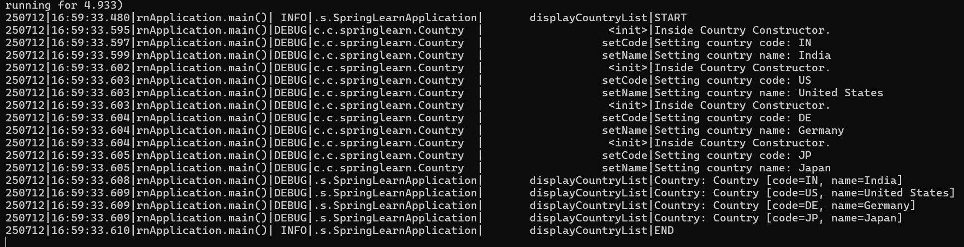

**Exercise 3: Hello World RESTful Web Service**

**//HelloController.java**

package com.cognizant.springlearn.controller;

import org.slf4j.Logger;

import org.slf4j.LoggerFactory;

import org.springframework.web.bind.annotation.GetMapping;

import org.springframework.web.bind.annotation.RestController;

@RestController

public class HelloController {

private static final Logger LOGGER = LoggerFactory.getLogger(HelloController.class);

@GetMapping("/hello")

public String sayHello() {

LOGGER.info("START");

LOGGER.info("END");

return "Hello World!!";

}

}

**Output:**

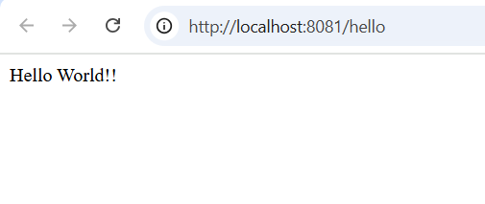

**Exercise 2: REST - Country Web Service**

**//** **CountryController.java**

package com.cognizant.springlearn.controller;

import com.cognizant.springlearn.Country;

import org.slf4j.Logger;

import org.slf4j.LoggerFactory;

import org.springframework.web.bind.annotation.RequestMapping;

import org.springframework.web.bind.annotation.RestController;

import org.springframework.context.ApplicationContext;

import org.springframework.context.support.ClassPathXmlApplicationContext;

@RestController

public class CountryController {

private static final Logger LOGGER = LoggerFactory.getLogger(CountryController.class);

@RequestMapping("/country")

public Country getCountryIndia() {

LOGGER.info("START");

ApplicationContext context = new ClassPathXmlApplicationContext("country.xml");

Country country = (Country) context.getBean("country", Country.class);

LOGGER.debug("Country: {}", country);

LOGGER.info("END");

return country;

}

}  
  
**Output:**

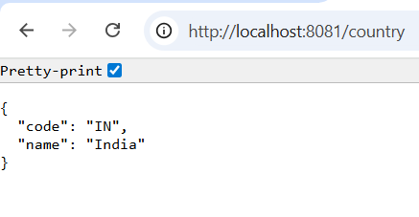

**Exercise 5: REST - Get country based on country code**

**//** **CountryController.java**

package com.cognizant.springlearn.controller;

import com.cognizant.springlearn.Country;

import org.slf4j.Logger;

import org.slf4j.LoggerFactory;

import org.springframework.context.ApplicationContext;

import org.springframework.context.support.ClassPathXmlApplicationContext;

import org.springframework.web.bind.annotation.GetMapping;

import org.springframework.web.bind.annotation.PathVariable;

import org.springframework.web.bind.annotation.RestController;

import java.util.List;

@RestController

public class CountryController {

private static final Logger LOGGER = LoggerFactory.getLogger(CountryController.class);

@GetMapping("/country")

public Country getCountryIndia() {

LOGGER.info("START getCountryIndia()");

ApplicationContext context = new ClassPathXmlApplicationContext("country.xml");

Country country = context.getBean("country", Country.class);

LOGGER.debug("Country: {}", country);

LOGGER.info("END getCountryIndia()");

return country;

}

@GetMapping("/countries")

public List<Country> getAllCountries() {

LOGGER.info("START getAllCountries()");

ApplicationContext context = new ClassPathXmlApplicationContext("country.xml");

List<Country> countries = context.getBean("countryList", List.class);

LOGGER.debug("Country List: {}", countries);

LOGGER.info("END getAllCountries()");

return countries;

}

@GetMapping("/countries/{code}")

public Country getCountry(@PathVariable String code) {

LOGGER.info("START getCountry() with code: {}", code);

ApplicationContext context = new ClassPathXmlApplicationContext("country.xml");

List<Country> countries = context.getBean("countryList", List.class);

for (Country c : countries) {

if (c.getCode().equalsIgnoreCase(code)) {

LOGGER.info("END getCountry() - country found");

return c;

}

}

LOGGER.info("END getCountry() - country not found");

return null; // or throw exception

}

}

**//Output:**

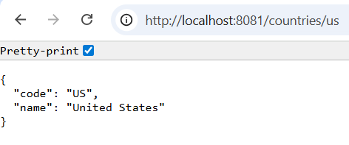

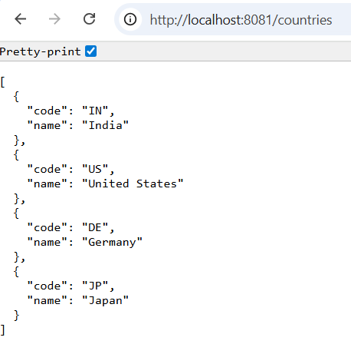

**Exercise 6: Create authentication service that returns JWT**

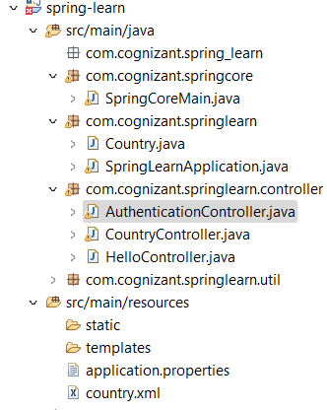

**//pom.xml**

<project xmlns=*"http://maven.apache.org/POM/4.0.0"*

xmlns:xsi=*"http://www.w3.org/2001/XMLSchema-instance"*

xsi:schemaLocation=*"http://maven.apache.org/POM/4.0.0*

*http://maven.apache.org/xsd/maven-4.0.0.xsd"*>

<modelVersion>4.0.0</modelVersion>

<parent>

<groupId>org.springframework.boot</groupId>

<artifactId>spring-boot-starter-parent</artifactId>

<version>3.2.5</version>

<relativePath/> <!-- lookup parent from repository -->

</parent>

<groupId>com.cognizant</groupId>

<artifactId>spring-learn</artifactId>

<version>0.0.1-SNAPSHOT</version>

<packaging>jar</packaging>

<name>spring-learn</name>

<description>Demo Spring Web Project with Logging</description>

<properties>

<java.version>17</java.version>

</properties>

<dependencies>

<!-- Spring Boot Starter Web -->

<dependency>

<groupId>org.springframework.boot</groupId>

<artifactId>spring-boot-starter-web</artifactId>

</dependency>

<!-- Spring Boot DevTools -->

<dependency>

<groupId>org.springframework.boot</groupId>

<artifactId>spring-boot-devtools</artifactId>

<scope>runtime</scope>

</dependency>

<!-- Spring Boot Starter Test -->

<dependency>

<groupId>org.springframework.boot</groupId>

<artifactId>spring-boot-starter-test</artifactId>

<scope>test</scope>

</dependency>

<dependency>

<groupId>io.jsonwebtoken</groupId>

<artifactId>jjwt-api</artifactId>

<version>0.11.5</version>

</dependency>

<dependency>

<groupId>io.jsonwebtoken</groupId>

<artifactId>jjwt-impl</artifactId>

<version>0.11.5</version>

<scope>runtime</scope>

</dependency>

<dependency>

<groupId>io.jsonwebtoken</groupId>

<artifactId>jjwt-jackson</artifactId>

<version>0.11.5</version>

<scope>runtime</scope>

</dependency>

</dependencies>

<build>

<plugins>

<plugin>

<groupId>org.springframework.boot</groupId>

<artifactId>spring-boot-maven-plugin</artifactId>

<configuration>

<mainClass>com.cognizant.springlearn.SpringLearnApplication</mainClass>

</configuration>

</plugin>

</plugins>

</build>

</project>

**//** **AuthenticationController**

**package** com.cognizant.springlearn.controller;

**import** com.cognizant.springlearn.util.JwtUtil;

**import** org.springframework.beans.factory.annotation.Autowired;

**import** org.springframework.http.ResponseEntity;

**import** org.springframework.util.Base64Utils;

**import** org.springframework.web.bind.annotation.*;

**import** java.nio.charset.StandardCharsets;

@RestController

**public** **class** AuthenticationController {

@Autowired

**private** JwtUtil jwtUtil;

@GetMapping("/authenticate")

**public** ResponseEntity<?> authenticate(@RequestHeader("Authorization") String authHeader) {

String[] credentials = extractCredentials(authHeader);

String username = credentials[0];

String password = credentials[1];

// Normally verify with DB or in-memory users; for now hardcoded

**if** (username.equals("user") && password.equals("pwd")) {

String token = jwtUtil.generateToken(username);

**return** ResponseEntity.*ok*().body("{\"token\":\"" + token + "\"}");

} **else** {

**return** ResponseEntity.*status*(401).body("Unauthorized");

}

}

**private** String[] extractCredentials(String authHeader) {

String base64Credentials = authHeader.substring("Basic ".length()).trim();

**byte**[] credDecoded = Base64Utils.decodeFromString(base64Credentials);

String credentials = **new** String(credDecoded, StandardCharsets.***UTF_8***);

**return** credentials.split(":", 2);

}

}

**// JwtUtil.java**

package com.cognizant.springlearn.util;

import io.jsonwebtoken.Jwts;

import io.jsonwebtoken.SignatureAlgorithm;

import io.jsonwebtoken.security.Keys;

import org.springframework.stereotype.Component;

import java.security.Key;

import java.util.Date;

@Component

public class JwtUtil {

private final Key key = Keys.secretKeyFor(SignatureAlgorithm.HS256); // Generates secure random key

public String generateToken(String username) {

return Jwts.builder()

.setSubject(username)

.setIssuedAt(new Date(System.currentTimeMillis()))

.setExpiration(new Date(System.currentTimeMillis() + 1000 * 60 * 60)) // 1 hour

.signWith(key)

.compact();

}

}

**Output:**

